Capstone Project Problem Statement Form
Spring 2026

Please complete this form with as much detail as available and submit it, along with any questions, to Lauren Darga, ldarga@uchicago.edu, or Alison Ossyra, aossyra@uchicago.edu. We will review with instructors and staff and may coordinate a short conversation to refine the statement and discuss data readiness. Once the proposal is approved and matched to a student team, MS in Applied Data Science staff will make introductions to launch the project. For more details, review this Sponsor Guide.

Organization
Organization Name |  | N/A - Research Project
Logo (include and/or attach)
Background/description/profile
Organization website
Has your organization sponsored an MS-ADS Capstone project before?
If yes, when, and was it the same topic, a continuation, or a new project?
Project
Title  Concise and descriptive |  | Large Concept Modeling for Structured Reasoning: An Applied Evaluation of Sentence-Level Generative Models
Statement of Work
Describe the project, business problem, or opportunity  What is most intriguing and compelling about this project for students? |  | This project investigates Large Concept Modeling (LCM) as an alternative representational approach for structured reasoning tasks in applied language modeling. Rather than modeling text as sequences of discrete tokens, the project explores whether modeling language at the sentence level, using semantic representations of entire sentences, can better capture long-range reasoning structure in complex analytical domains.  The applied problem motivating this work is that many existing language models rely on token-level prediction, which can result in weak global coherence, limited interpretability, and poor control over reasoning structure in long-form analytical outputs. These limitations are particularly evident in domains such as legal analysis and decision-support systems, where outputs must follow clear logical progressions and apply consistent rules. As a result, real-world deployments often rely on additional post-processing or “wrapper” layers to mitigate hallucinations and reasoning errors. This project examines whether sentence-level generative modeling can reduce these issues by explicitly modeling higher-level semantic structure.  To evaluate this opportunity, the project will develop and analyze a prototype LCM pipeline that operates on sequences of sentence-level representations. Legal texts will be segmented into sentences and encoded into fixed-dimensional semantic embeddings. A sequence model will be trained to learn patterns across these sentence representations, and a decoding component will be used to reconstruct natural language from generated embeddings for evaluation purposes. Model outputs will be analyzed qualitatively and quantitatively to assess coherence, consistency, and reasoning structure relative to token-level baselines.  The legal domain is used as a controlled testbed due to its structured reasoning patterns and the availability of public data. In particular, employment discrimination cases provide consistent logical frameworks involving legal standards and rule application, making them well suited for evaluating long-range reasoning behavior. The project scope is intentionally constrained to a limited corpus and baseline modeling approaches to ensure feasibility within the capstone timeline.  Overall, this project aims to provide applied empirical evidence on the strengths and limitations of sentence-level generative modeling for structured reasoning, with the goal of informing future use of Large Concept Modeling as a complement to existing language modeling approaches.
Preferred student skill sets to help the project be successful  Click here to view MS-ADS curriculum |  | - Python programming  - PyTorch and ML workflows  - Familiarity with embeddings and transformer-based models and their architecture  - Unstructured text data experience  - Ability to deconstruct and foresee what proper responses should be  - Prior legal knowledge not needed (used solely as a use case for this architecture)
Data
Critical requirement: Organization will need to allow access to, provision of, and review of data with team(s) by Monday, April 6 (week 2 of the Spring quarter).
Description |  | The dataset consists of judicial opinions and written decisions from employment discrimination cases. The primary training dataset will be drawn from New York state and federal employment discrimination cases. Additional employment discrimination cases from other U.S. jurisdictions will be held out for evaluation and generalization testing.
Source |  | - Free Law Project (CourtListener and RECAP) API  - U.S. Courts PACER (Public Access to Court Electronic Records)  - Google Scholar (as needed, depending on extra context that may be necessary)  - New York Official Reports Legal Research Portal (web-scraped rules and regulations)
Does the data currently exist?  If yes, how will it be shared?  If no, how/when will it be acquired, and how/when will it be accessible by the student team? |  | The data exists and most of it is publicly available. The data will be collected and scraped as needed and then organized into .txt files. After preprocessing, the dataset will be stored in a shared folder (Google Drive). Processed datasets (like the sentence-level files and embedding arrays) will be shared via a version-controlled repository on GitHub or via cloud storage.
How big is the data set?  How many rows/columns? Gigabytes? How many files? |  | The project will target approximately 1,000 unique case opinions, each stored as an individual .txt file. After sentence-level preprocessing, this is expected to yield on the order of at least 50,000 sentences. Additional aggregated or “master” text files (such as grouped by jurisdiction or case type) might need to be created for training convenience. The total data size is expected to be approximately 1–3 GB, including raw text and stored sentence embeddings.
What is the nature of the data (does the data contain structured or unstructured elements? Is it time-series, signal-based, images, text, etc.)?  Please provide a sample of the data. |  | The data consists of unstructured text, specifically legal opinions and judicial reasoning which is all-natural language text that will be segmented at the sentence level.  Example:  “The court finds that the plaintiff has failed to establish a prima facie case of discrimination under the applicable standard.”
Will students be required to use any particular platform, environment, language, etc. to work with the data? |  | The following tools will be used:  - Python for data processing and modeling  - PyTorch for model training  - HuggingFace Transformers and sentence-transformers libraries  - Cloud computing (GCP) might need to be used for training if local runtimes are especially slow
Describe the available data documentation and attach a data dictionary if available. |  | Data dictionary will be developed throughout the natural course of this research project. However, for the publicly available sources, various dictionaries are available based on the data being used. Here is the relational schema for the data from CourtListener from the FreeLawProject.
How will students access data?  Your network? Google Cloud or AWS? Downloaded to their own devices? Other? |  | Data will be downloaded to local machines for preprocessing and analysis. For compute-intensive training, data and models might be stored and accessed via GCP.
Is a Non-Disclosure Agreement (NDA) required for the student team? |  | No. All data is publicly shared and available. NDAs may be needed for reuse and applicative purposes beyond the capstone project.
Expected Results
Deliverables, output, etc.  As a class assignment, students will complete a research paper and Showcase presentation; other deliverables may include models, plans, code, analysis, etc. | - Research Paper:  A research paper documenting the problem, motivation for Large Concept Modeling, dataset construction, modeling approach, and experimental evaluation. The paper will emphasize empirical findings and insights regarding sentence-level generative modeling for structured reasoning,  - Capstone Showcase Presentation:  A technical presentation delivered to the capstone showcase audience, summarizing the methodology, modeling framework, experimental design, evaluation results, and key findings of our research.  - Reproducible Technical Artifacts and Research Assets:  A collection of technical artifacts supporting the research, including:  - Data artifacts: curated and preprocessed sentence-level datasets derived from publicly available legal texts, with clear documentation of preprocessing and splitting strategies  - Modeling artifacts: prototype sentence-level sequence models and decoding components used in experimentation, along with trained model outputs where applicable  - Code and workflows: scripts and notebooks for data preprocessing, model training, generation, and evaluation, organized to support reproducibility and inspection  - Configuration and documentation: configuration files, experiment logs, and written documentation enabling others to understand and reproduce the experimental setup  - Evaluation Framework and Benchmarking Results: A structured evaluation framework designed to assess sentence-level generative modeling relative to token-based language modeling baselines.  This will include quantitative and qualitative benchmarks comparing:  - output coherence and semantic consistency  - reconstruction fidelity and long-range reasoning behavior  - computational characteristics such as model complexity and relative resource requirements  - strengths and trade-offs of sentence-level versus token-level architectures  The benchmarking results will provide applied evidence to inform if, when, and how Large Concept Modeling may be advantageous and improve upon current LLMs in higher level structured reasoning tasks.
Capstone project descriptions may be used on program websites or in other materials. If you do not want your project included, please opt out by clicking the check box: ☐
Organization Contacts
Primary point of contact for the project
Name:
Title:
Department:
Work email address:
Work or cell phone number:
Primary point of contact for data (if different from the primary project contact)
Name:
Title:
Department:
Work email address:
Work or cell phone number:
Secondary contact(s)
Name:
Title:
Department:
Work email address:
Work or cell phone number:

Name:
Title:
Department:
Work email address:
Work or cell phone number:
Project Timelines
Capstone projects span two academic quarters and conclude with a Showcase.

Most projects start in March, and students take a break over the summer to complete internships before concluding in December, with the Showcase on Saturday, December 5, 2026, following this timeline:
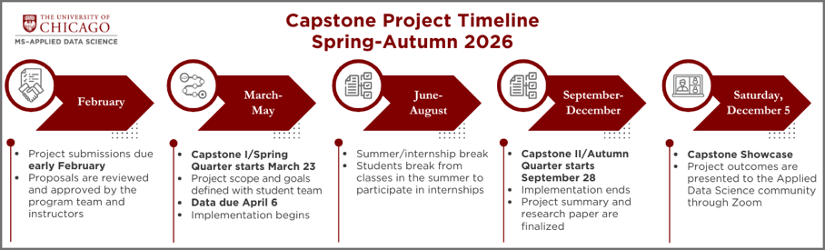
A smaller number of students forego an internship; in those cases, projects start in March and conclude in August, with the Showcase on Saturday, August 15, 2026, following this timeline:
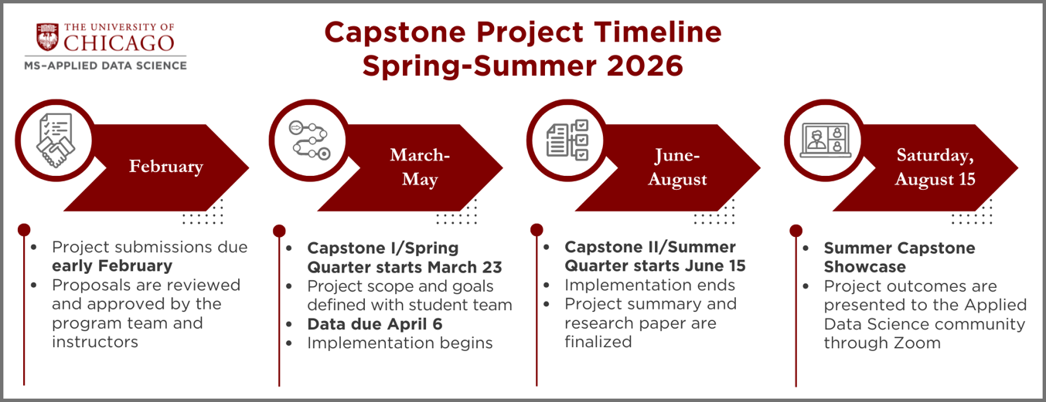

Although not guaranteed, please indicate if you have a project timeline preference  No preference, Autumn, or Summer |  | Spring -> Summer
Student Proposed Project
If this is a Student Proposed project, list all team members |  | For each team member, identify each member’s CNet and program modalities (full time or part time, in-person or online)
Student 1: Nicholas Dhaliwal  Student 2: Jaysen Jensen  Student 3: Nicholas Mikhail  Student 4: |  | Student 1: nicholasdhaliwal@uchicago.edu; Full-Time  Student 2: jaysen@uchicago.edu; Part-Time  Student 3: nmikhail@uchicago.edu; Full-Time  Student 4:
MS in Applied Data Science Internal Use
Proposal reviewed and approved by
Date approved

